**Солдатова ФБ-11мп**

**Task 1**

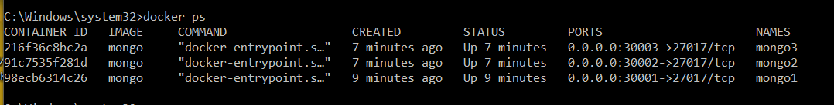

my-mongo-set:PRIMARY> rs.status()

{

"set" : "my-mongo-set",

"date" : ISODate("2021-11-22T20:55:35.784Z"),

"myState" : 1,

"term" : NumberLong(1),

"syncSourceHost" : "",

"syncSourceId" : -1,

"heartbeatIntervalMillis" : NumberLong(2000),

"majorityVoteCount" : 2,

"writeMajorityCount" : 2,

"votingMembersCount" : 3,

"writableVotingMembersCount" : 3,

"optimes" : {

"lastCommittedOpTime" : {

"ts" : Timestamp(1637614535, 1),

"t" : NumberLong(1)

},

"lastCommittedWallTime" : ISODate("2021-11-22T20:55:35.367Z"),

"readConcernMajorityOpTime" : {

"ts" : Timestamp(1637614535, 1),

"t" : NumberLong(1)

},

"appliedOpTime" : {

"ts" : Timestamp(1637614535, 1),

"t" : NumberLong(1)

},

"durableOpTime" : {

"ts" : Timestamp(1637614535, 1),

"t" : NumberLong(1)

},

"lastAppliedWallTime" : ISODate("2021-11-22T20:55:35.367Z"),

"lastDurableWallTime" : ISODate("2021-11-22T20:55:35.367Z")

},

"lastStableRecoveryTimestamp" : Timestamp(1637614505, 1),

"electionCandidateMetrics" : {

"lastElectionReason" : "electionTimeout",

"lastElectionDate" : ISODate("2021-11-22T20:50:15.184Z"),

"electionTerm" : NumberLong(1),

"lastCommittedOpTimeAtElection" : {

"ts" : Timestamp(1637614204, 1),

"t" : NumberLong(-1)

},

"lastSeenOpTimeAtElection" : {

"ts" : Timestamp(1637614204, 1),

"t" : NumberLong(-1)

},

"numVotesNeeded" : 2,

"priorityAtElection" : 1,

"electionTimeoutMillis" : NumberLong(10000),

"numCatchUpOps" : NumberLong(0),

"newTermStartDate" : ISODate("2021-11-22T20:50:15.306Z"),

"wMajorityWriteAvailabilityDate" : ISODate("2021-11-22T20:50:16.030Z")

},

"members" : [

{

"_id" : 0,

"name" : "mongo1:27017",

"health" : 1,

"state" : 1,

"stateStr" : "PRIMARY",

"uptime" : 600,

"optime" : {

"ts" : Timestamp(1637614535, 1),

"t" : NumberLong(1)

},

"optimeDate" : ISODate("2021-11-22T20:55:35Z"),

"syncSourceHost" : "",

"syncSourceId" : -1,

"infoMessage" : "",

"electionTime" : Timestamp(1637614215, 1),

"electionDate" : ISODate("2021-11-22T20:50:15Z"),

"configVersion" : 1,

"configTerm" : 1,

"self" : true,

"lastHeartbeatMessage" : ""

},

{

"_id" : 1,

"name" : "mongo2:27017",

"health" : 1,

"state" : 2,

"stateStr" : "SECONDARY",

"uptime" : 330,

"optime" : {

"ts" : Timestamp(1637614525, 1),

"t" : NumberLong(1)

},

"optimeDurable" : {

"ts" : Timestamp(1637614525, 1),

"t" : NumberLong(1)

},

"optimeDate" : ISODate("2021-11-22T20:55:25Z"),

"optimeDurableDate" : ISODate("2021-11-22T20:55:25Z"),

"lastHeartbeat" : ISODate("2021-11-22T20:55:35.257Z"),

"lastHeartbeatRecv" : ISODate("2021-11-22T20:55:34.273Z"),

"pingMs" : NumberLong(0),

"lastHeartbeatMessage" : "",

"syncSourceHost" : "mongo1:27017",

"syncSourceId" : 0,

"infoMessage" : "",

"configVersion" : 1,

"configTerm" : 1

},

{

"_id" : 2,

"name" : "mongo3:27017",

"health" : 1,

"state" : 2,

"stateStr" : "SECONDARY",

"uptime" : 330,

"optime" : {

"ts" : Timestamp(1637614525, 1),

"t" : NumberLong(1)

},

"optimeDurable" : {

"ts" : Timestamp(1637614525, 1),

"t" : NumberLong(1)

},

"optimeDate" : ISODate("2021-11-22T20:55:25Z"),

"optimeDurableDate" : ISODate("2021-11-22T20:55:25Z"),

"lastHeartbeat" : ISODate("2021-11-22T20:55:35.258Z"),

"lastHeartbeatRecv" : ISODate("2021-11-22T20:55:34.272Z"),

"pingMs" : NumberLong(0),

"lastHeartbeatMessage" : "",

"syncSourceHost" : "mongo1:27017",

"syncSourceId" : 0,

"infoMessage" : "",

"configVersion" : 1,

"configTerm" : 1

}

],

"ok" : 1,

"$clusterTime" : {

"clusterTime" : Timestamp(1637614535, 1),

"signature" : {

"hash" : BinData(0,"AAAAAAAAAAAAAAAAAAAAAAAAAAA="),

"keyId" : NumberLong(0)

}

},

"operationTime" : Timestamp(1637614535, 1)

}

**Task 2**

Unacknowledged:

db.inventory.insert({"category":"Phone","model":"Xiaomi Redmi 13", "producer":"Xiaomi", "price":4500},{writeConcern: {w:0}});

Acknowledged:

db.inventory.insert({"category":"Phone","model":"Big Galaxer", "producer":"Samsung", "price":3700},{writeConcern: {w:1}});

Journaled:

db.inventory.insert({"category":"Phone","model":"Smart iPhone", "producer":"Apple", "price":5000},{writeConcern: {w:1, j:true}});

AcknowledgedReplica:

db.inventory.insert({"category":"Phone","model":"Redmi Five", "producer":"Xiaomi", "price":1700},{writeConcern: {w:2}});

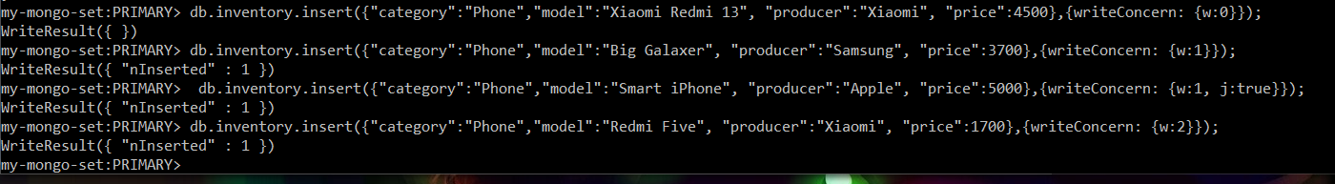

**Task 3**

Secondary Node:

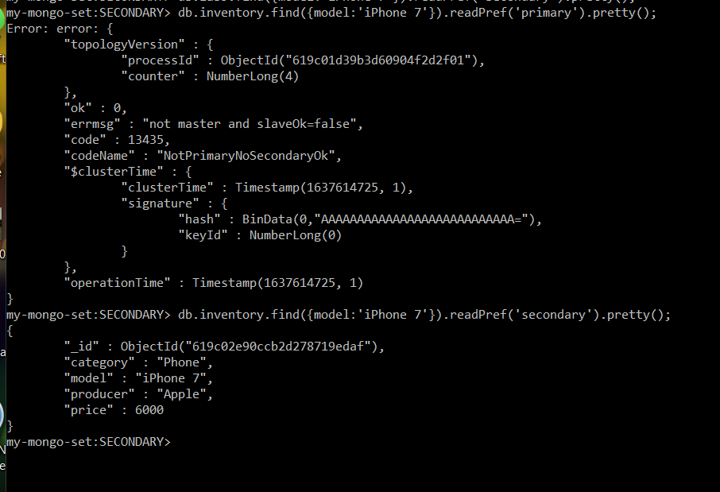

Primary Node:

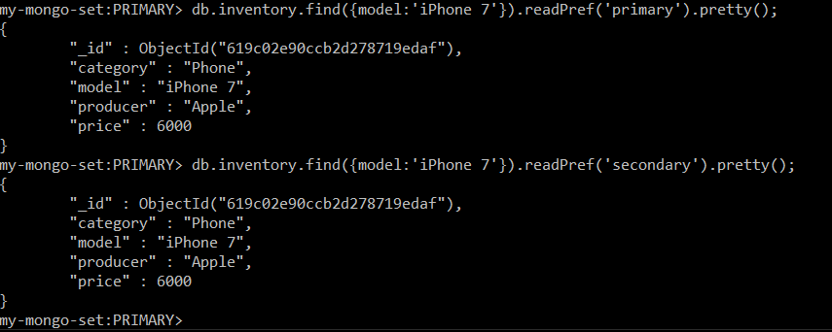

**Task 4**

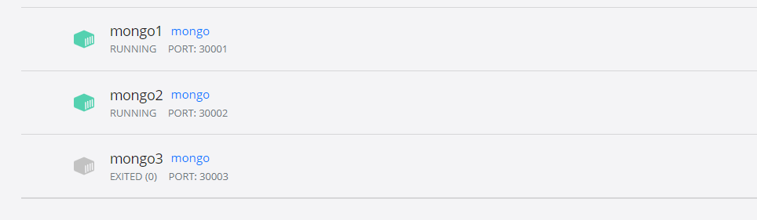



Was inserted after starting third node

**Task 5**

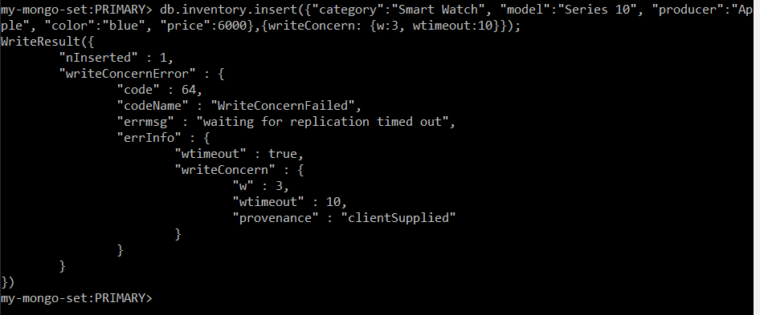

**Task 6**

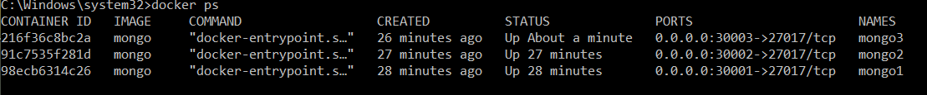

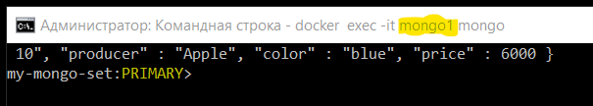

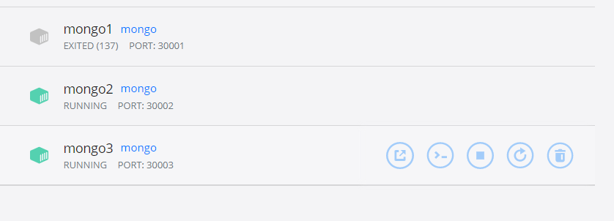

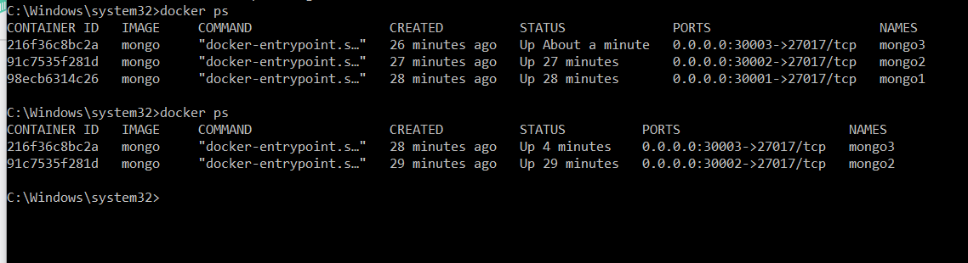

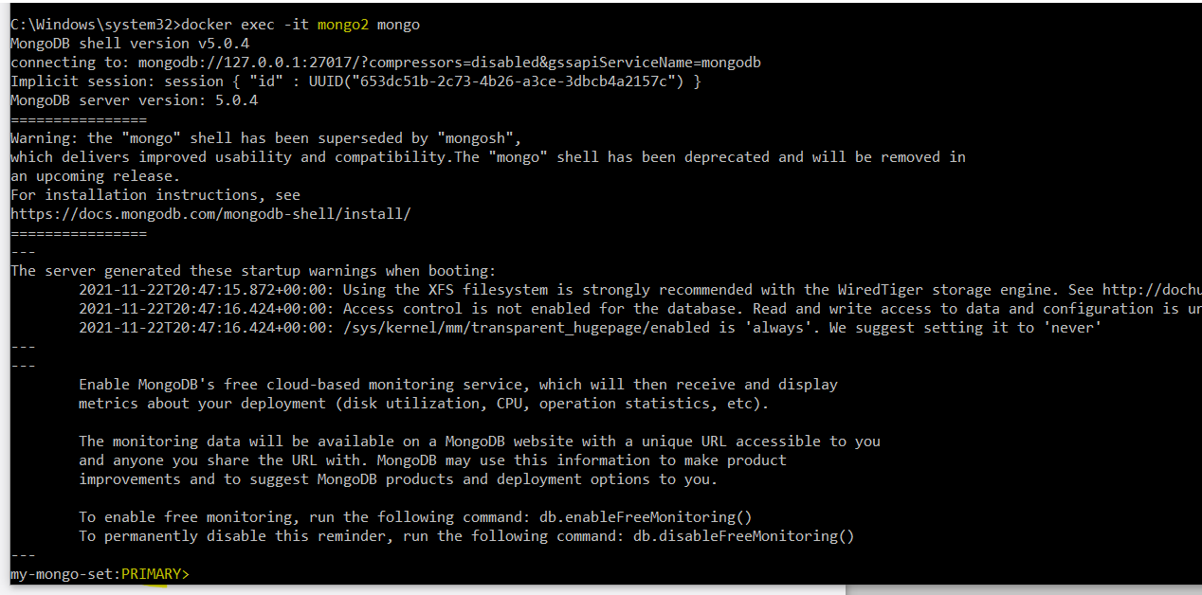

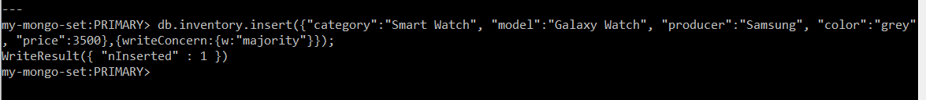

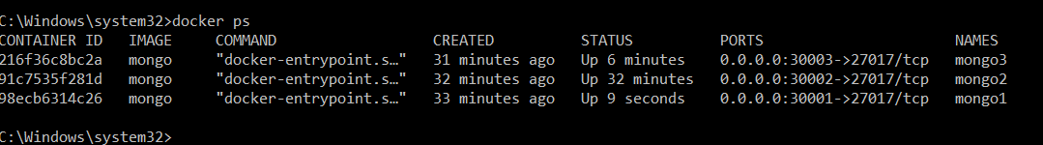

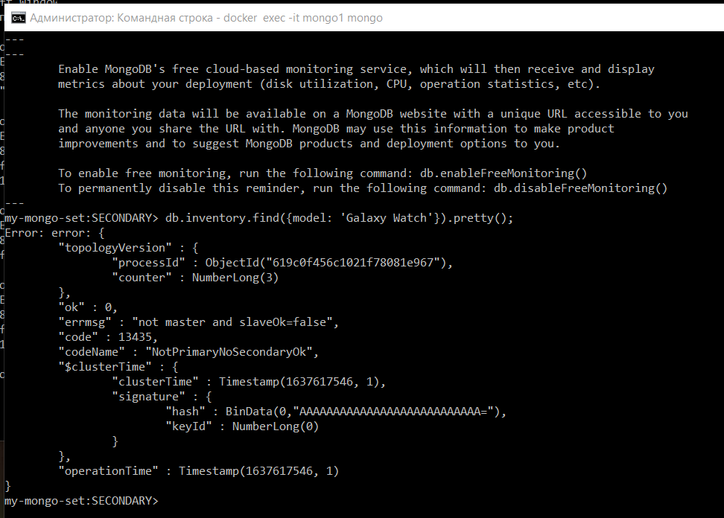

**Task 7**

Two nodes are off.

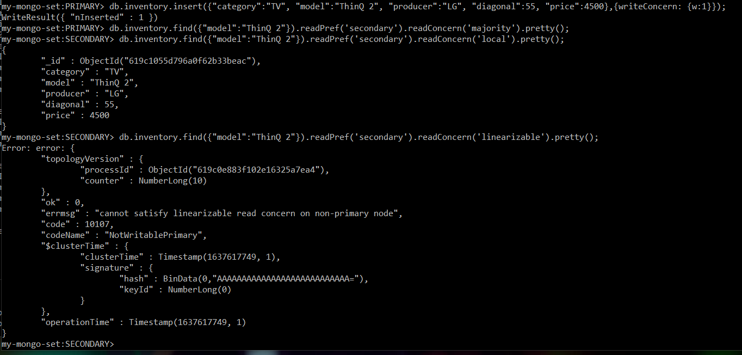

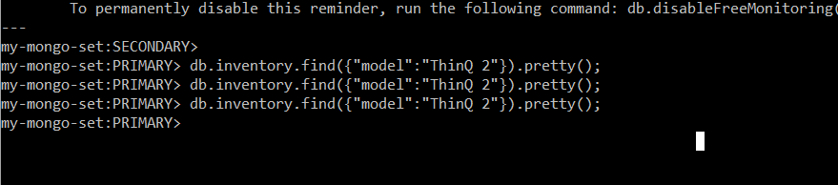

No matches were found for this query.

**Task 8**

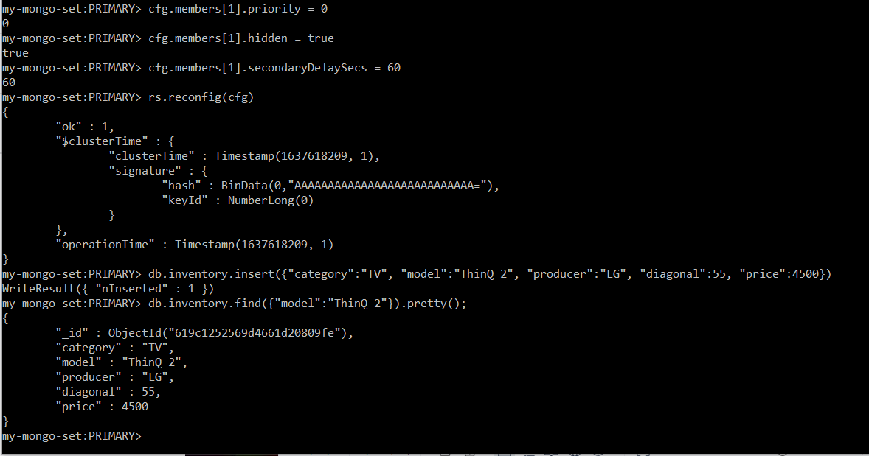

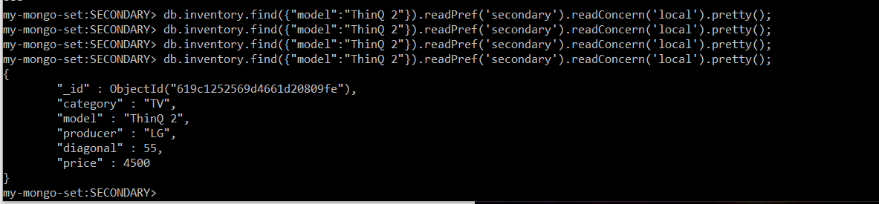

**Task 9**

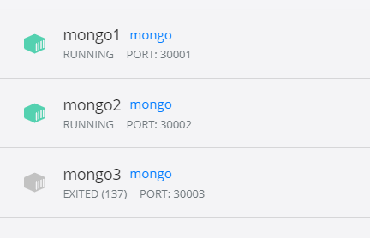

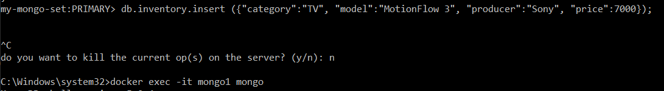

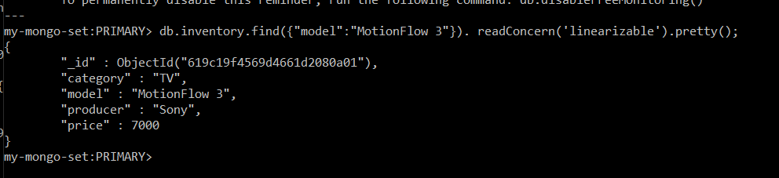The resuits were presented with a delay.